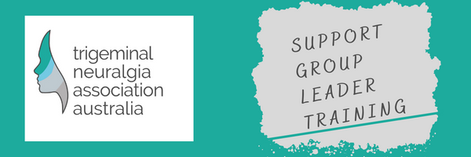
Support Group Leader Training – Information
Subject: Video Presentation – Trigeminal Neuralgia: Symptoms, diagnosis and treatment

Trigeminal neuralgia is a neurological condition which can cause pain around the eyes, cheek and jaw. In this illuminating online interview, highly respected consultant neurosurgeon Mr Jeremy Rowe gives an expert guide to the condition's diagnosis and treatment.

Video Presentations - Trigeminal Neuralgia Association Australia (tnaaustralia.org.au)

Questions answered through the video

0:00 How is trigeminal neuralgia defined?
1:34 What are the warning signs of trigeminal neuralgia?
1:59 Who is most at risk from suffering from trigeminal neuralgia?
3:20 How is trigeminal neuralgia diagnosed?
4:28 What are the different treatment options? Is trigeminal neuralgia life-threatening?

Please refer to this Knowledge Sheet – Interview with Mr Jeremy Rowe as a training resource

