Support Group Leader Training – Information 3
Subject: Video Presentation – Trigeminal Neuralgia Pain – Dr Jennifer Robblee

Trigeminal neuralgia differs from other types of facial pain. How? Why? Who does it affect? Dr. Jennifer Robblee, a headache neurologist at Barrow in Phoenix, Arizona, discusses.
Video Presentations - Trigeminal Neuralgia Association Australia (tnaaustralia.org.au)
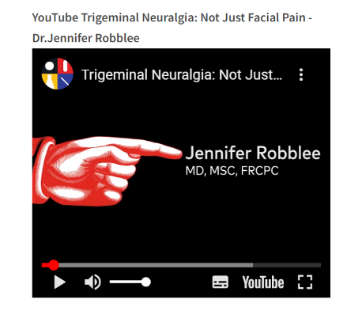

Please refer to this Knowledge Video – TN Pain with Dr Jennifer Robblee as a training resource

